

Department of Computer Science

Maqsood Ahmed 38186
PF Assignment : 03

Question 01[CLO3: C3][20]

Part A

Write a program of currency converter using functions:
1. Press 1 :Call function which convert Pakistani Rs in to euro
2. Press 2 :Call function which convert euro to yen
3. Press 3 :Dollar in to euro
4. Press 4 :Pakistani Rs to dollar
5. Press 5 :Dollar in to yen

Source Code:

#include <iostream>
using namespace std;

double rupeesToEuro(double currency) {
return (currency * 0.0033);
}

double euroToYen(double currency) {
return (currency * 161.4041);
}

double dollarToEuro(double currency) {
return (currency * 1.0895);
}

double rupeesToDollar(double currency) {
return (currency * 0.0036);
}

double dollarToYen(double currency) {
return (currency * 148.1455);
}

void currencyConverterMenu() {
int choice; double amount;
do {
system("clear"); // clears the screen
cout << "\nPress 1 :Call function which convert Pakistani Rs in to euro\n"
<< "Press 2 :Call function which convert euro to yen\n"
<< "Press 3 :Dollar in to euro\n"
<< "Press 4 :Pakistani Rs to dollar\n"
<< "Press 5 :Dollar in to yen \n";
cout << ">> ";
cin >> choice;
} while(!(choice > 0 && choice < 6));

cout << "Enter amount: ";
cin >> amount;

switch (choice)
{
case 1:
cout << "Converted amount is: " << rupeesToEuro(amount) << '\n';
break;

case 2:
cout << "Converted amount is: " << euroToYen(amount) << '\n';
break;

case 3:
cout << "Converted amount is: " << dollarToEuro(amount) << '\n';
break;

case 4:
cout << "Converted amount is: " << rupeesToDollar(amount) << '\n';
break;

case 5:
cout << "Converted amount is: " << dollarToYen(amount) << '\n';
break;

default:
break;
}

}

int main(void) {

currencyConverterMenu();

return EXIT_SUCCESS;
}

OUTPUT:

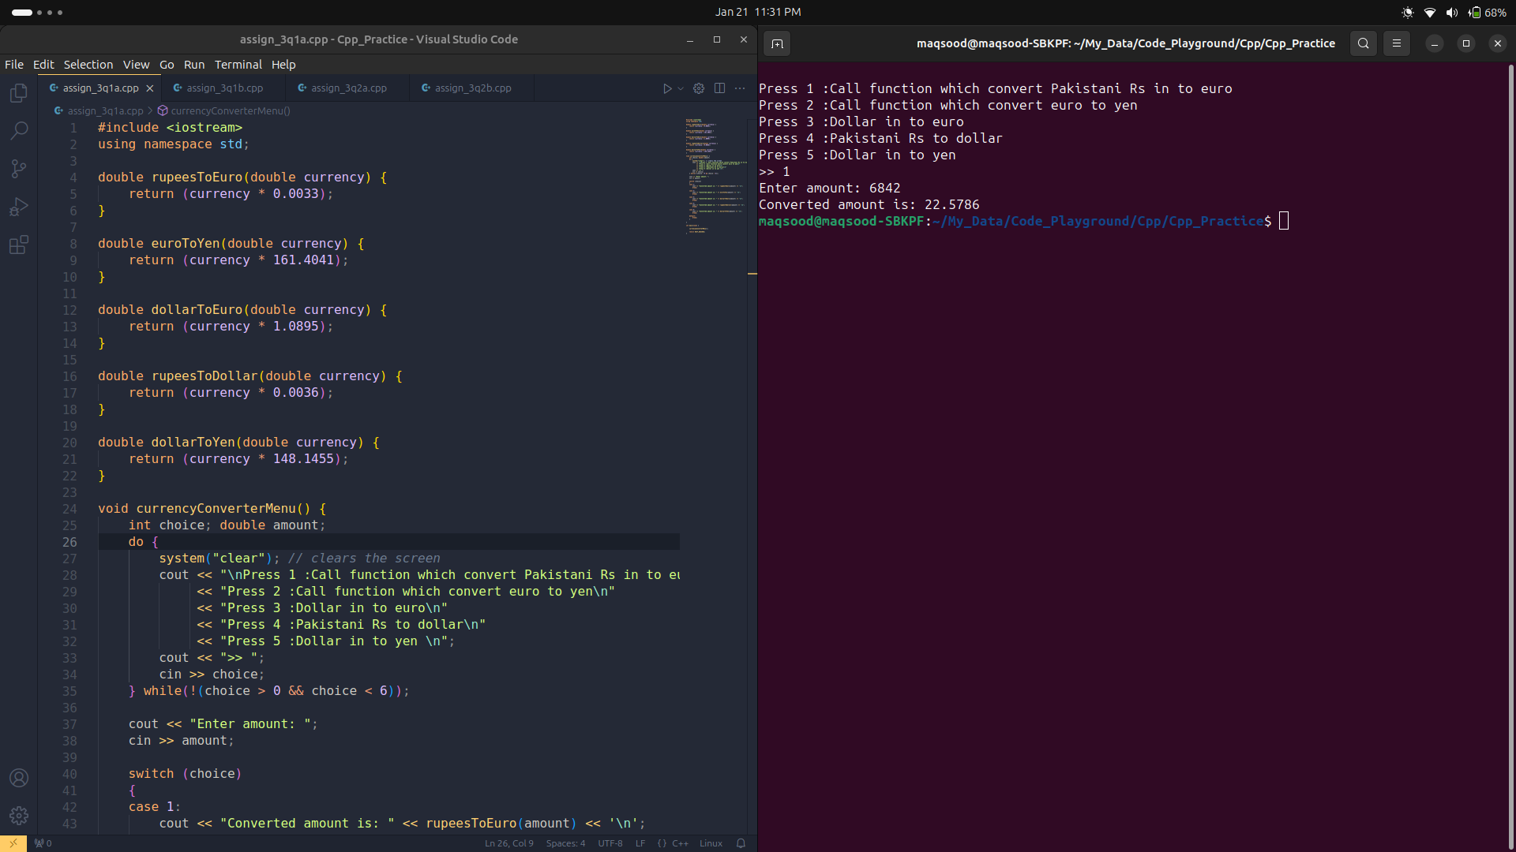

Part B

Write a program which takes 10 student marks from user. The system shall allow user to use three functionalities i.e. insert (), delete(), update(). All the student marks are inserted in an array via functions.

Source Code:

#include <iostream>
using namespace std;

void insert(int arr[]) {

int index;

cout << "Enter the index where you want to insert(0-9): ";
cin >> index;

if(index >= 0 && index < 10) {
cout << "What you want to insert: ";
cin >> arr[index];
cout << "Successfully inserted!\n";

} else {
cout << "Size exceeded! Try again\n";
insert(arr);
}
}

void update(int arr[]) {

int index;

cout << "Enter the index where you want to update(0-9): ";
cin >> index;

if(index >= 0 && index < 10) {
cout << "What you want to update: ";
cin >> arr[index];
cout << "Successfully updated!\n";

} else {
cout << "Size exceeded! Try again\n";
update(arr);
}
}

void delete_(int arr[]) {

int index;

cout << "Enter the index where you want to delete(0-9): ";
cin >> index;

if(index >= 0 && index < 10) {
cout << "Successfully deleted!\n";
arr[index] = 0;
} else {
cout << "Size exceeded! Try again\n";
delete_(arr);
}
}

int main(void) {

const int SIZE = 10; // constant size
int array[SIZE];

int choice;

do {
system("clear"); // clears the screen
cout << "\nPress 1 :to insert\n"
<< "Press 2 :to update\n"
<< "Press 3 :to delete\n";
cout << ">> ";
cin >> choice;
} while(!(choice > 0 && choice < 3));

switch (choice)
{
case 1:
insert(array);
break;

case 2:
update(array);
break;

case 3:
delete_(array);
break;

default:
break;
}

return EXIT_SUCCESS;
}

OUTPUT:

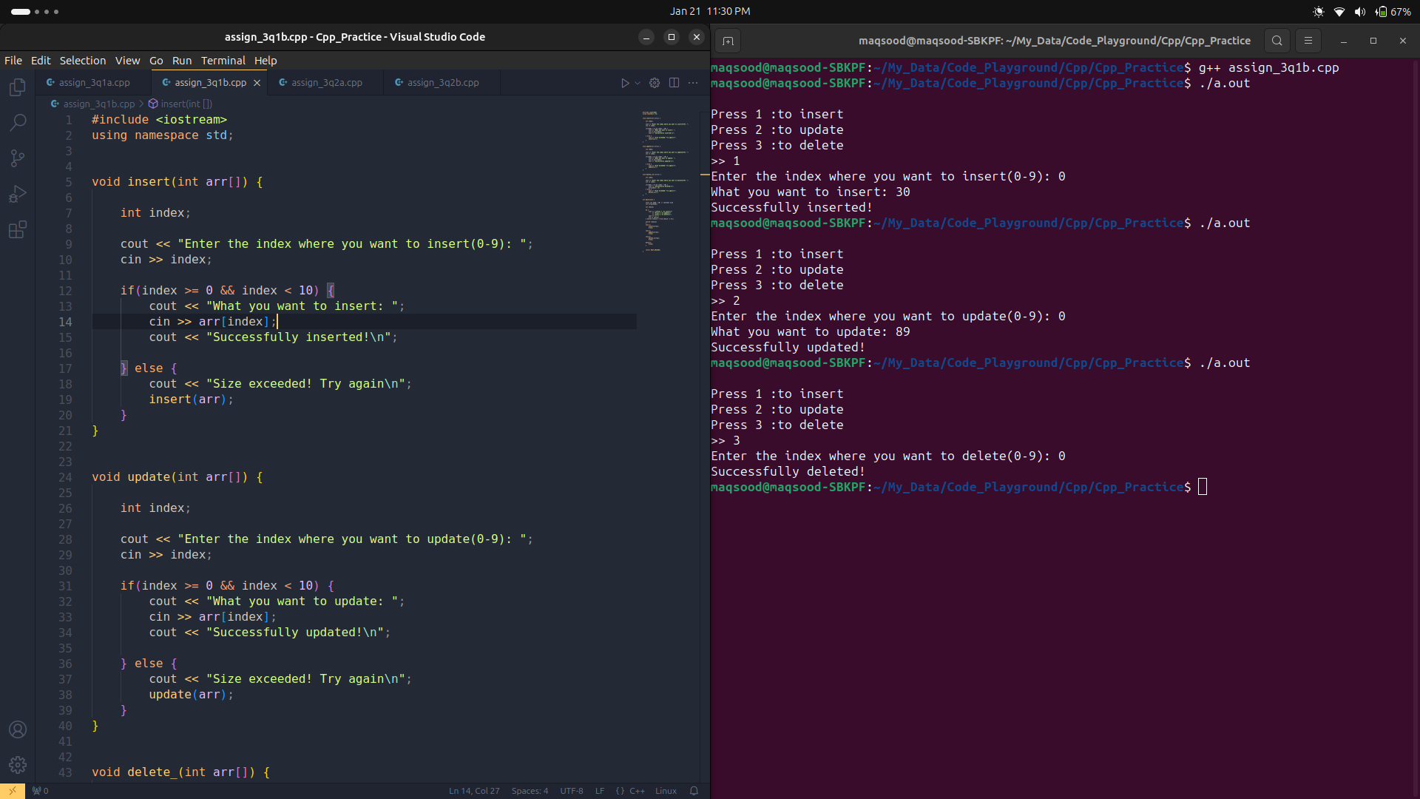

Question 02[CLO3: C3][20]

Part A

Write a C++ program that creates a structure called course that contains two members
- Name (string)
- Credit hr(int)

After that creates a structure called student that contains the following data members.
- Name(string)
- Age(int)
- Cms(int)
- Semester(int)
- Course (course)

Take the data member’s value from the user and display the record of the 3 students.

Source Code:

#include <iostream>
using namespace std;

struct Course {
string course_name;
int credit_hr;
};

struct Student {
string name;
int age;
int cms;
int semester;
Course course;
};

// takes student record from user as input
void getStudentRecord(Student &student) {

cout << "Enter your name: ";
cin >> student.name;
cout << "Enter your age: ";
cin >> student.age;
cout << "Enter your cms: ";
cin >> student.cms;
cout << "Enter your semester: ";
cin >> student.semester;
cout << "Enter your course name: ";
cin >> student.course.course_name;
cout << "Enter credit hours: ";
cin >> student.course.credit_hr;
}

// displays student record
void displayStudentRecord(Student &student) {
cout << "\n------------------------------------------------\n";
cout << "Student name: " << student.name << '\n';
cout << "Student age: " << student.age << '\n';
cout << "Student cms: " << student.cms << '\n';
cout << "Enrolled semester: " << student.semester << '\n';
cout << "Course name: " << student.course.course_name << '\n';
cout << "Student Name: " << student.course.credit_hr << '\n';
}

int main(void) {

system("clear"); // clears the screen

Student student[3];
for(int i = 0; i < 3; i++) {
cout << "\n------------------------------------------------\n";
cout << "\t\t STUDENT: " << i + 1 << "\n\n";
getStudentRecord(student[i]);
}

system("clear"); // clears the screen

for(int i = 0; i < 3; i++) {
cout << "\t\t STUDENT: " << i + 1 << "\n\n";
displayStudentRecord(student[i]);
}

return EXIT_SUCCESS;
}

OUTPUT:

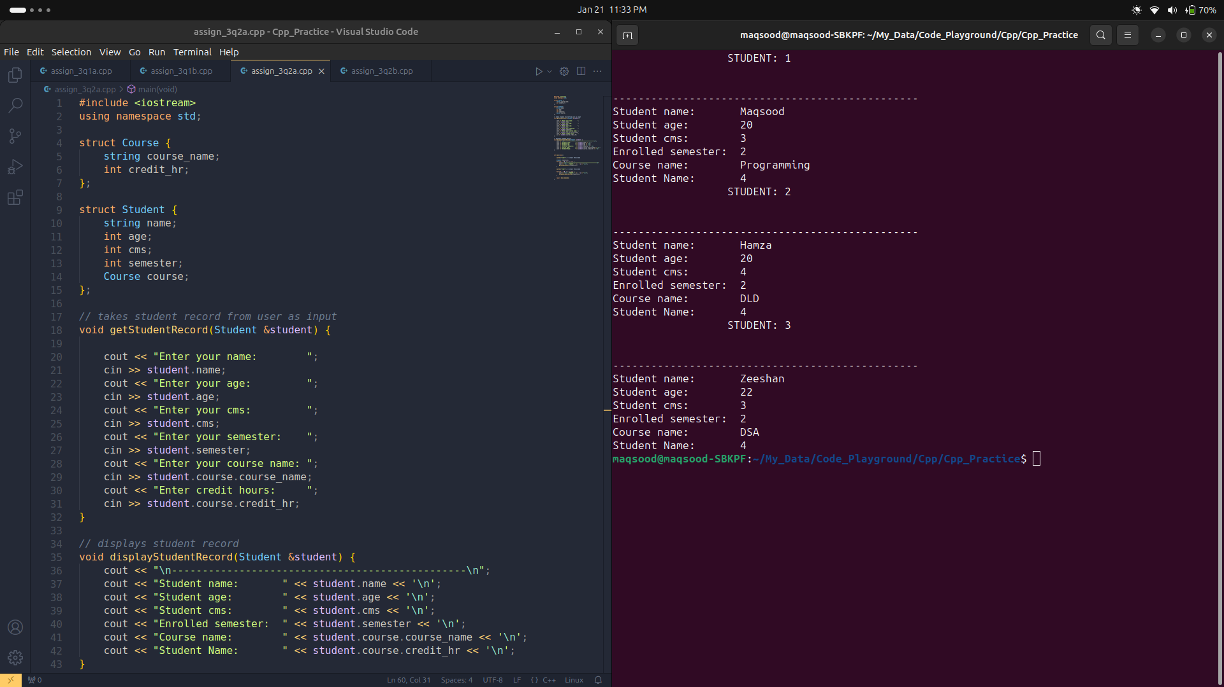

Part B

Write a C++ program that creates a structure to manage a record of employee. Employee
has 4 attribute.
- Employee id
- Employee Name
- Employee age
- Employee salary
Make a structure of employee having provided attributes and store 10 employee data and display it. Also display the name of those employee whose salary is greater than 5000.

Source Code:

#include <iostream>
using namespace std;

struct Employee {
int employee_id;
string employee_name;
int employee_age;
int employee_salary;
};

// takes student record from user as input
void getEmployeeRecord(Employee &employee) {

cout << "Enter your name: ";
cin >> employee.employee_name;
cout << "Enter your id: ";
cin >> employee.employee_id;
cout << "Enter your age: ";
cin >> employee.employee_age;
cout << "Enter your salary: ";
cin >> employee.employee_salary;

}

// displays student record
void displayEmployeeRecord(Employee &employee) {

cout << "\n------------------------------------------------\n";
cout << "Employee name: " << employee.employee_name << '\n';
cout << "Employee id: " << employee.employee_id << '\n';
cout << "Employee age: " << employee.employee_age << '\n';
cout << "Employee salary: " << employee.employee_salary << '\n';
}

// displays record of employee whose salary is greater the 5000
void displayEmployeeNameSalaryGreaterThan5k(Employee &employee) {

if(employee.employee_salary >= 5000) {
cout << "Employee name: " << employee.employee_name << '\n';
}
}

int main(void) {
Employee employee[10];

for(int i = 0; i < 10; i++) {
cout << "\n------------------------------------------------\n";
cout << "\t\t EMPLOYEE: " << i + 1 << "\n\n";
getEmployeeRecord(employee[i]);
}

system("clear"); // clears the screen

for(int i = 0; i < 10; i++) {
cout << "\t\t EMPLOYEE: " << i + 1 << "\n\n";
displayEmployeeRecord(employee[i]);
}

cout << "Displaying Employee name's whose salary is greater than 5k\n";
for(int i = 0; i < 10; i++) {
displayEmployeeNameSalaryGreaterThan5k(employee[i]);
}
return EXIT_SUCCESS;
}
OUTPUT:
